## ALL EVENTS API

## 1. ALL EVENTS ( GET METHOD )

## Request:

|  |
| --- |
| **URL** |
| http://localhost:5000/api/allevents |

|  |  |
| --- | --- |
| **Parameters** | **Types** |
| * limit * latitude * longitude * radius | int  double  double  int |

## Sample Response: ( Array of Json Objects )

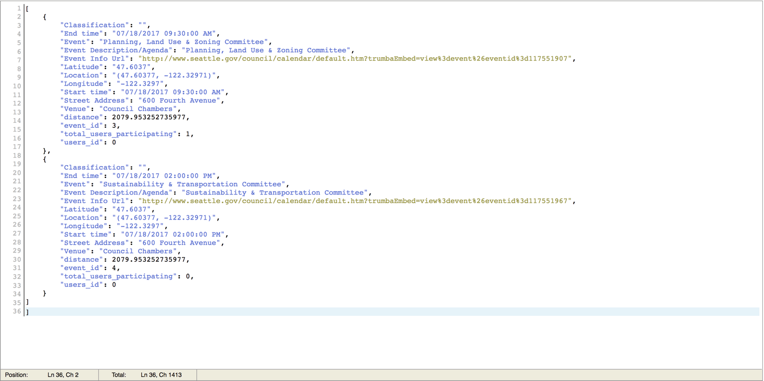

### **Tool:**

I used postman to test my API instead of curl. It is a Google Chrome extension and I found this tool helpful as it has a nice little user interface where you can put the parameters, select If it’s a GET or a POST request and it also displays the response in a very clean fashion.

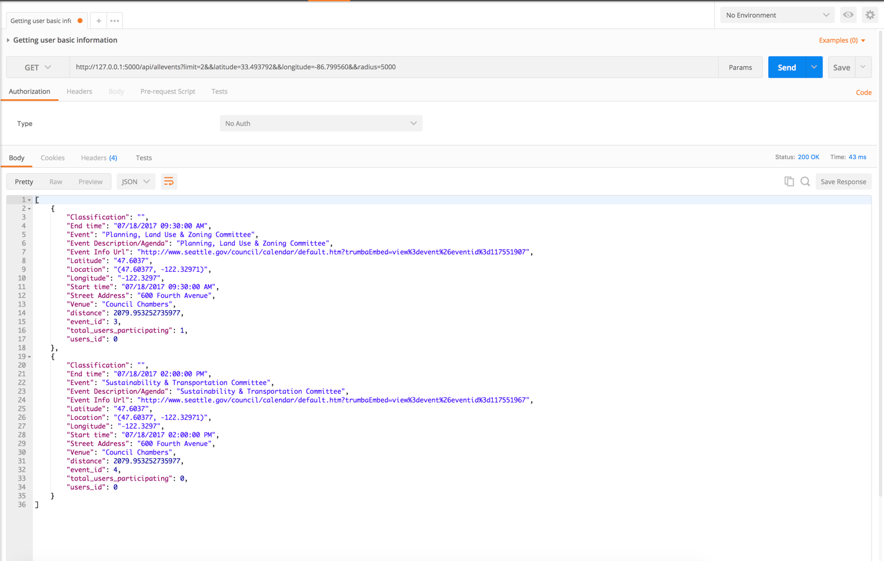

### **Explanation of Request Parameters:**

**Limit**: The limit variable limits the number of rows that the user wants to fetch in the API.

If you want to fetch all the rows, you can put the value 0 and it will return all the events that we have in our database.

**Latitude**: User should send his latitude so he can calculate the nearby events within a certain radius. If the user doesn’t want to send his latitude, he/she can put 00.00 instead.

**Longitude**: User should send his longitude so he can calculate the nearby events within a certain radius. If the user doesn’t want to send his longitude, he/she can put 00.00 instead.

**Radius**: User can define a certain radius, and then the API will calculate the Euclidean distance between his location and the events location and then only fetch rows that are within that radius. If the user does not send his latitude and longitude, then this radius functionality won’t work. Similarly, if the user is not interested in viewing the events within a certain radius, he/she can just put 0 instead and it will fetch all the events sorted with respect to time stamp instead.